IT Employee Management System
Step 1: Database Schema Requirements
Entities:
- Employee
- Department
- Project
- Skill
- EmployeeSkill (Many-to-Many)
- ProjectAssignment (Many-to-Many)

Step 2: SQL Script to Create the Schema
Creating Database – IT_Employee
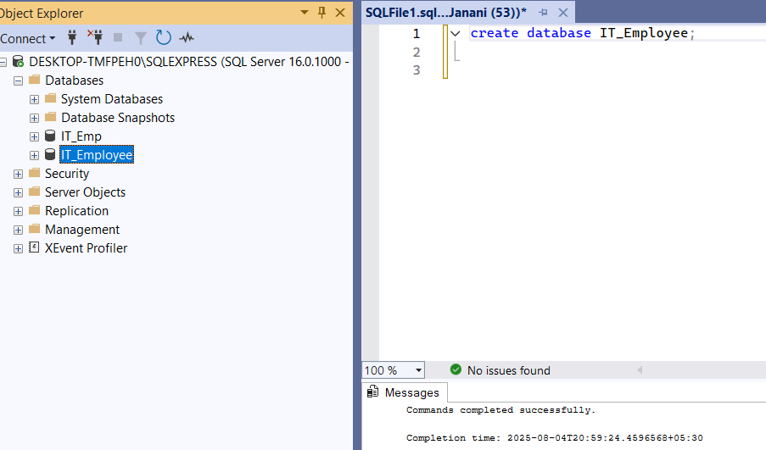

Department Table:
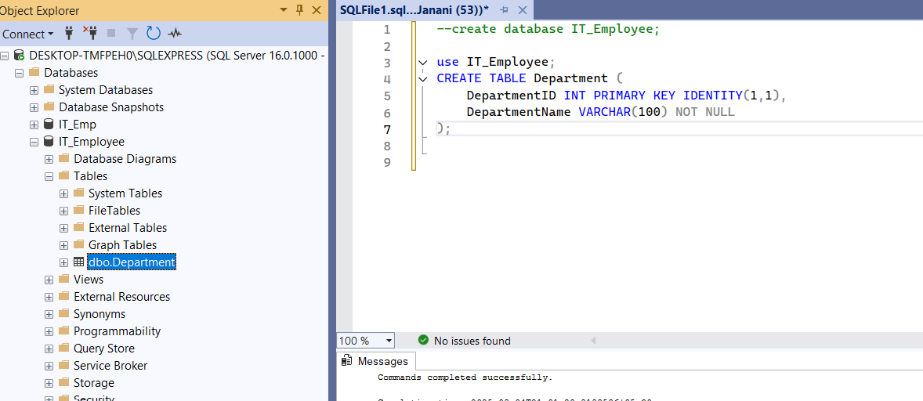

Employee Table:
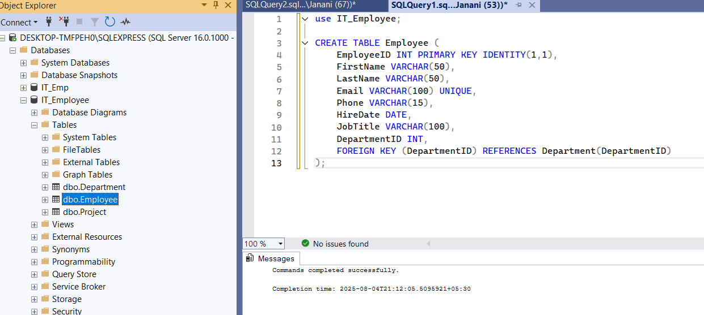

Project Table:
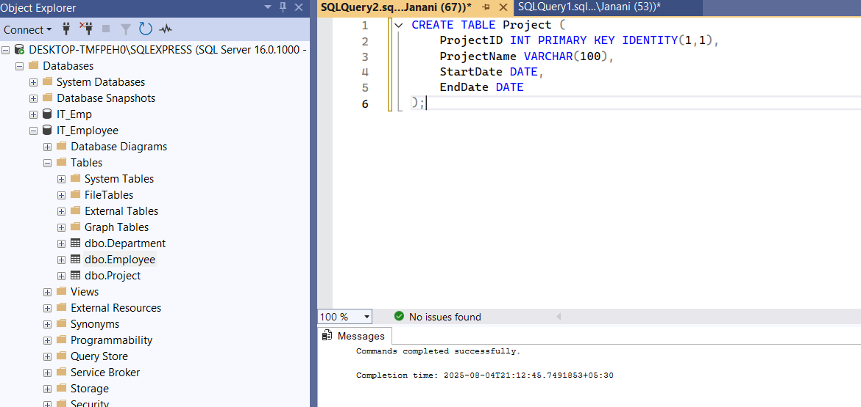

Skill Table:
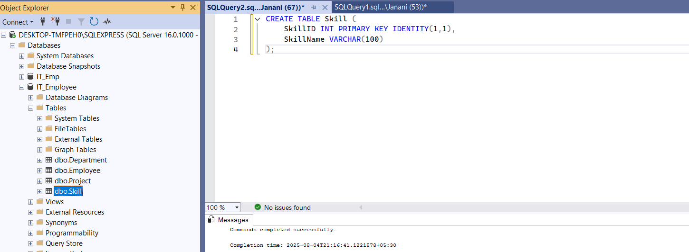

Employee Skill Table:
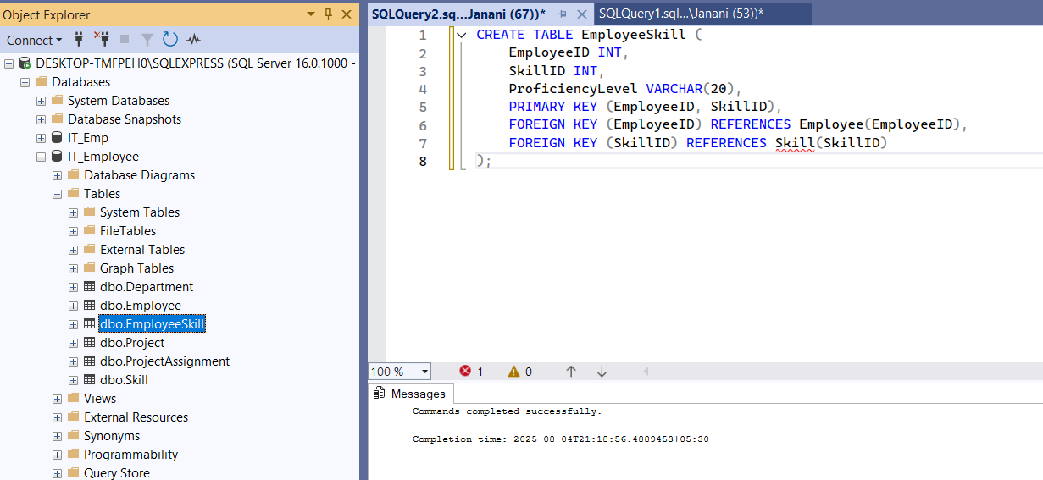

Project Assignment Table:
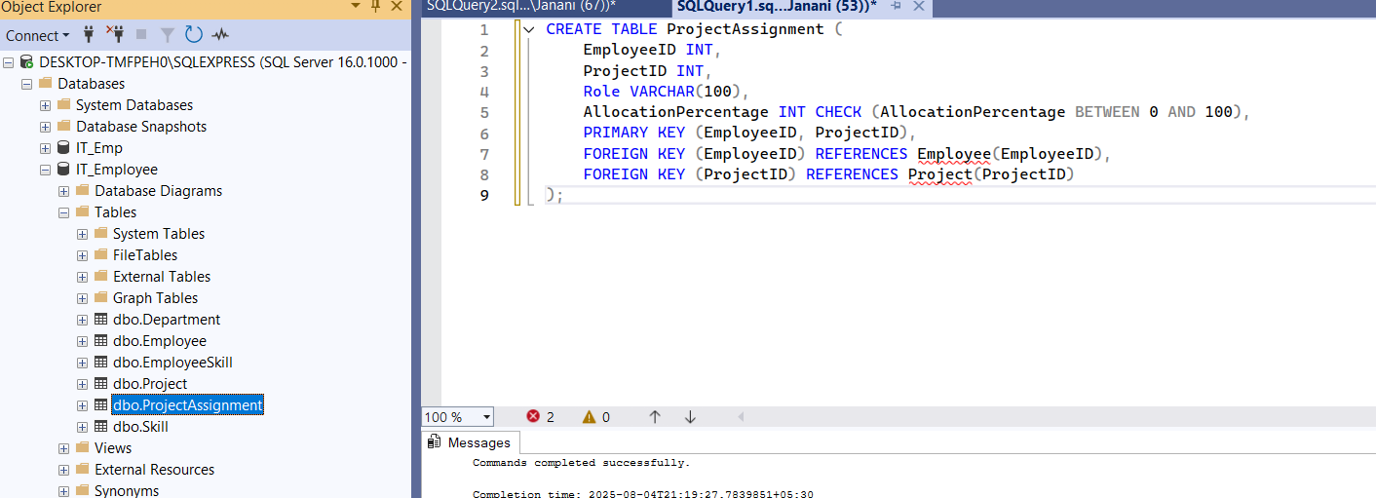

Step 3: ER Diagram Description
Here’s how the ER diagram will look:
Entities and Attributes
- Department
  - DepartmentID (PK)
  - DepartmentName
- Employee
  - EmployeeID (PK)
  - FirstName
  - LastName
  - Email
  - Phone
  - HireDate
  - JobTitle
  - DepartmentID (FK)
- Project
  - ProjectID (PK)
  - ProjectName
  - StartDate
  - EndDate
- Skill
  - SkillID (PK)
  - SkillName
- EmployeeSkill
  - EmployeeID (FK)
  - SkillID (FK)
  - ProficiencyLevel

- ProjectAssignment
  - EmployeeID (FK)
  - ProjectID (FK)
  - Role
  - AllocationPercentage

Relationships
- Department —< Employee (One-to-Many)
- Employee —< EmployeeSkill >— Skill (Many-to-Many)
- Employee —< ProjectAssignment >— Project (Many-to-Many)
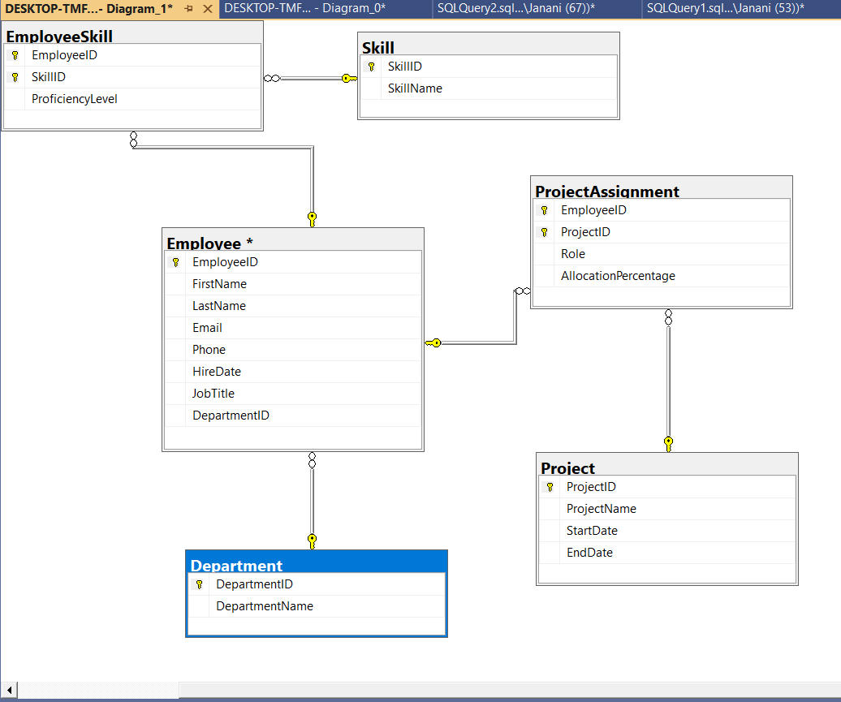

Thank you!

